***SPONSOR A BIN - ITAMARACÁ***

**More details…**

The sole business of Itamaracá is tourism – there is nothing else. Lack of rubbish management adversely affects tourism.

Tourism brings income to businesses, jobs are created and thus taxes are paid to the town hall. Anything that reduces tourism (like piles of rubbish) costs the town hall money. Residents can earn more money by taking greater care when disposing of rubbish, as this will result in an increase in tourism – creating jobs.

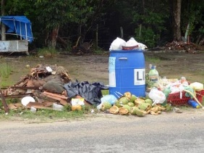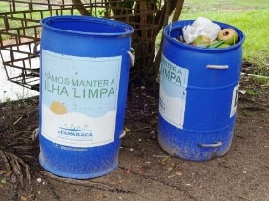The recent provision of drums is an improvement on what went before, but the town hall simply does not have the funds to purchase more. The island is not allowed by law to have any kind of industry, (as most of it is a protected rain forest), and so tax income is severely limited.

The services offered by the town hall have to be balanced by the low source of income, and this means that, quite naturally, health care and support for the poor take preference over rubbish collection and environmental education in local schools.

We are a group of volunteers, active in the local community, and part of a small Brazilian business association here, called AMICRO ("Association of Micro Businesses"). Along with other locals, we carry out volunteer work in the community to encourage tourism, jobs and environmental education on the island.

This fundraising initiative is both environmental and educational in nature, and we could really could do with your support – right now there are simply not enough drums…. So please Sponsor a Bin.

To resolve the rubbish problem, we propose a 5-pronged approach:

**1/ Cleaning of beaches and roads.**

This is in-hand and ongoing with numerous local volunteers organising rubbish-picking groups all over the island.

**2/ Provision of containers for the public to deposit their rubbish.**

An additional 1100 x 200L recycled plastic drums to be placed along roads and at beach access points. **This is why we need sponsors.**

Wooden rubbish bins made from recycled pallets to be placed on beaches.

**3/ Emptying of the new drums.**

After much discussion, the Town Hall has agreed they are able to empty these new drums within the current system, as we will not actually be creating any more rubbish. It will just be easier and quicker for them to collect, since they will not have to pick up the majority by hand.

Each of the wooden bins on beaches will be adopted by a local who will take responsibility to place rubbish sacks inside, and bring them from the beach to one of the drums when full.

**4/ Prevention and Reduction of rubbish.**

One of the biggest sources of rubbish is the single-use plastic bags handed out by all the supermarkets on the island. We are planning to provide reusable cotton shopping bags free of charge to all the schoolchildren on the island, to present to their mothers.

**5/ Education.**

Signs and banners on roads and beach access points; school and church visits; social media; news outlet publicity.

To encourage locals and the town hall to recycle - some recycling exists now, but much more could be done.

Links to other projects on the island, such as the turtle and manatee projects, to keep environmental awareness high.

**WHY DO WE NEED MORE DRUMS? HOW MANY?**

The Environmental Protection Agency in the US states that each human creates about 2 litres of rubbish per day, and there are some 25,000 people resident on the island.

2L x 25,000 = 50,000L of rubbish per day

If each drum has a capacity of 200L, then we would need 250 drums to handle all the rubbish created by the residents of the island if every drum is emptied every day, 7 days a week.

We would need 875 drums if they are emptied twice a week

We would need 1750 drums if they are emptied once a week

We would need 3500 drums if they are emptied once every two weeks

Therefore to achieve the goal of emptying all drums once a week, with the 600+ drums already purchased by the town hall, we need to provide another 1100.

**THE DRUMS**

This is what we are buying: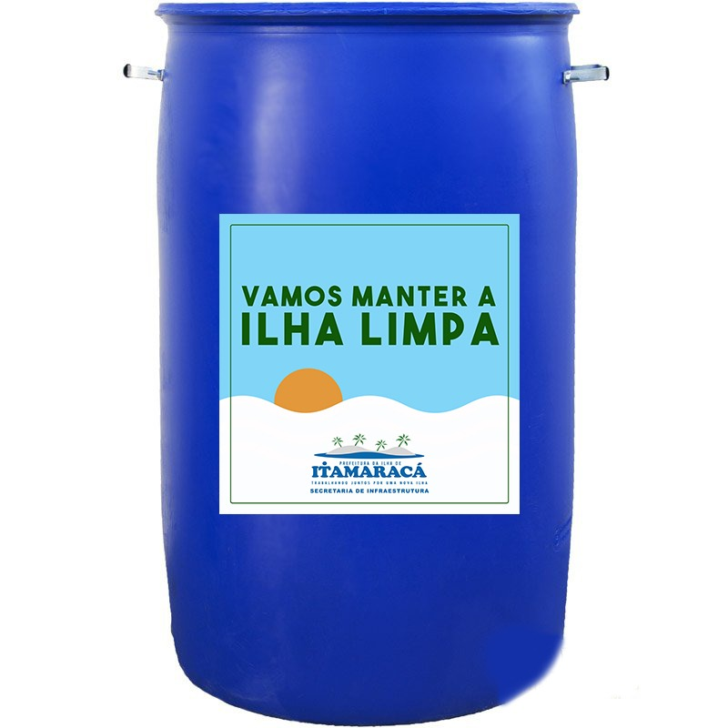

The goal of this project is to purchase 1100 x 200 litre, rigid, re-cycled plastic drums, with handles to facilitate emptying. They will be purchased in batches of 100 drums.

**Each bin costs just**

* **R$90 (BRL)**
* **$22 (USD)**
* **€20 (EUR)**
* **£17 (GBP**)

We appreciate any contribution to this project, and suggest a contribution of at least one bin but multiple bins would be ideal.

**Many thanks for your support!**